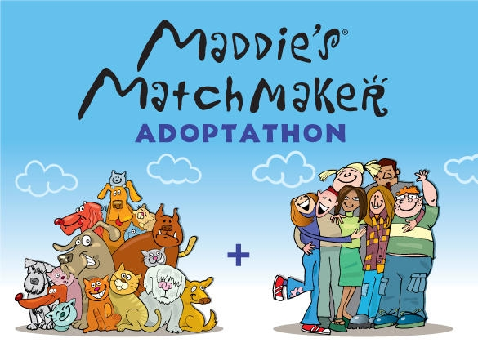
Dog and cat adoptions will be FREE to qualified homes and, better yet, every successful adoption will earn Oakland Animal Services a generous donation from Maddie’s Fund of $500 to $2,000.

SATURDAY, JUNE 9 & SUNDAY, JUNE 10

Shelter: Oakland Animal Services
Location: 1101 29th Ave. in Oakland
Time: 10am-8pm on Saturday
10am-5pm on Sunday
Date: June 9th and June 10th

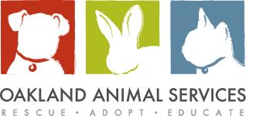 | 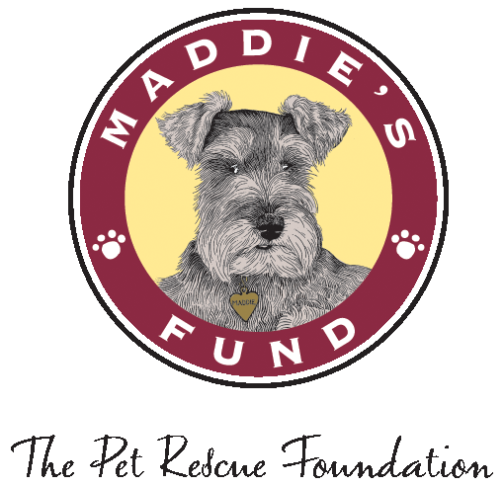 | Maddie’s® Matchmaker Adoptathon is being held in honor of a miniature schnauzer named Maddie. Maddie’s love, devotion, loyalty and spirit inspired her caregivers to start a charitable foundation in her name.

